DS.140 Integration Design Specification



HIS to Fusion Inventory Consumption Integration

SCM_RICE_004

Author: Pranjul Garg

Creation Date: Apr 25, 2022

Last Updated: Jun 26, 2023

Version: 2.0

**Approvals:**

|  |  |
| --- | --- |
| <Approver 1> | <Rakesh Khanna / Naushad / Amit> |
| <Approver 2> | <Business Owner> |

# Document Control

## Change Record

| **Date** | **Author** | **Version** | **Change Reference** |
| --- | --- | --- | --- |
| 25-Apr-2022 | Pranjul Garg | 1.0 | No Previous Document |
| 26-Jun-2033 | Ajay kumar | 2.0 | Reviewed |
|  |  |  |  |
|  |  |  |  |

2

## Reviewers

| **Name** | **Position** |
| --- | --- |
| FHL Business | Business User |
| FHL IT Group | Fortis IT Team |
|  |  |
|  |  |

Contents

**1** **Document Control ii**

1.1 Change Record ii

1.2 Reviewers ii

**2** **Introduction 4**

2.1.1 Scope for this Document 4

2.1.2 Intended Audience 4

**3** **Overview 5**

3.1 Business Objectives 5

3.2 Major Features 5

3.3 Glossary 5

**4** **High-Level HIS to Fusion Integration flow 6**

**5** **Technical Design Details 7**

5.1 OIC Services 7

5.2 Oracle PaaS DBCS components 8

5.3 Technical flow 9

**6** **Error Reprocessing & SWEEP 17**

**7** **HIS System 19**

7.1 HIS Services 19

**8** **Data FIELD Mapping 20**

8.1 File format 20

8.2 Frequency 20

**9** **Exception handling 21**

9.1 Scenarios 21

**10** **Assumptions / Considerations 23**

**11** **Open and Closed Issues 24**

11.1 Open Issues 24

11.2 Closed Issues 24

# Introduction

### Scope for this Document

This analysis specification document is prepared to layout the HIS to Fusion Inventory Consumption integration.

### Intended Audience

This document is intended for the following groups to provide the action items and consideration that are required to complete the implementation of the various Supply Chain and Finance related functionalities from Oracle Fusion.

#### Fortis Business Users

This document will be helpful for Fortis Business users to understand the technical design and process change with the new structure implemented in Oracle. The business user will validate this document after the verification of the requirement.

#### PwC Technical Team

The PwC technical team will use this document as a source technical design document to develop the technical solution to implement / deploy in Oracle Fusion.

#### Fortis IT Team

The Fortis IT Team must facilitate the PwC technical team for requisite details and other elements required from Business. The Fortis IT team is also responsible to arrange and provide required technical information wherever is required.

# Overview

Fortis Healthcare Limited (FHL) is a chain of hospitals, headquartered in India. Fortis started its health care operations from Mohali where the first Fortis hospital was started. Later, the hospital chain purchased the healthcare branch of the Escorts group and increased its strength in various parts of the country. The Fortis health care also operates its hospital in Vasant Kunj, Faridabad, Gurgaon. The FMRI hospital at Gurgaon is the headquarter of Fortis healthcare with all the major facilities at the hospital.

This specification document is prepared to layout the design of HIS to Fusion Inventory Consumption integration. Oracle PaaS DBCS has been used for validating the data before importing it to Oracle Fusion.

## Business Objectives

The following are the business objectives.

1. To have a secure, reliable, and scalable design flow from HIS to Oracle Fusion where the PaaS DBCS database acts as an intermediate layer to provide complete interface details.
2. To have a solution providing the monitoring capabilities.

## Major Features

The proposed solution will have the following features involved:

1. OIC integration as a REST Endpoint URL which is a starting point for HIS to invoke to interface a data file to Oracle fusion.
2. PLSQL packages & Shell scripts which exists in Oracle PaaS DBCS for data insertion into staging table, validation and preparing csv file in FBDI format to import the data in Oracle Fusion.

## Glossary

**REST**

Representational State Transfer.

**OIC**

Oracle Integration Cloud

# High-Level HIS to Fusion Integration flow

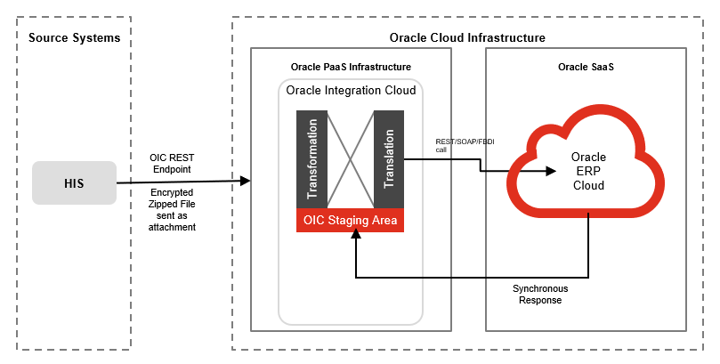

# Technical Design Details

This section describes the technical details of all the components involved in the design of HIS to Oracle Fusion Inventory Consumption integration.

## OIC Services

An App driven orchestration has been designed in OIC to build a REST Endpoint URL, which accepts the file as a binary attachment, along with its checksum and file name.

|  |  |
| --- | --- |
| **OIC Integration Name** | Fortis HIS To Fusion Inv Consumption Integration |
| **OIC REST Endpoint URL** | https://oic-prod-nr5lr39yailj-bo.integration.ocp.oraclecloud.com:443/ic/api/integration/v1/flows/rest/FORTIS_HIS_FUSION_INV_CONS_INTG/1.0/callOIC/fusionInbound/ |
| **Method** | POST |
| **Request Media Type** | application/zip |
| **Request Headers** | fileName  SourceChecksum |
| **Response Media Type** | application/json |
| **Response sample** | { "FileID":"12345", "status" : "Source-target checksum matches,data is being processed" } |

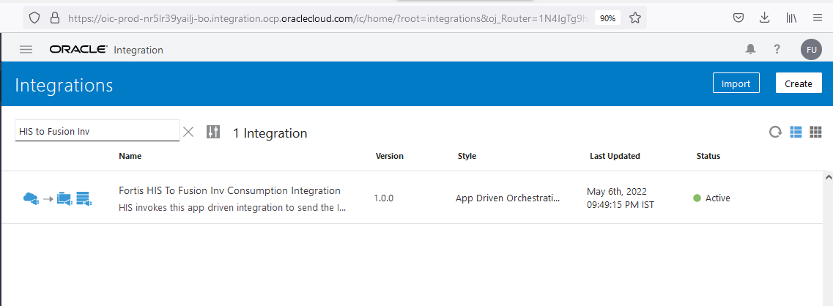

Following OIC Integration is also an app driven orchestration which is being invoked from a shell script which takes the file from SFTP and processes it in Oracle fusion by invoking seeded ESS jobs: Load Interface File for Import and Manage Inventory Transactions.

|  |  |
| --- | --- |
| **OIC Integration Name** | Fortis Inventory Consumption Process Integration |
| **OIC REST Endpoint URL** | https://oic-prod-nr5lr39yailj-bo.integration.ocp.oraclecloud.com:443/ic/api/integration/v1/flows/rest/FORTIS_INV_CONS_PROCESS_INTG/1.0/callOIC/processInvTransactions/ |
| **Method** | POST |
| **Request Media Type** | application/json |
| **Request sample** | { "FileId":"1234", "FileName" : "abc.zip" } |
| **Response Media Type** | application/json |
| **Response sample** | { "FlowId":"1234", "Status":"Processed successfully" } |

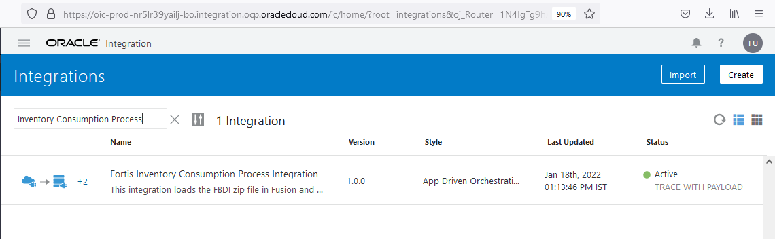

## Oracle PaaS DBCS components

This integration design uses the following components from Oracle PaaS DBCS:

|  |  |  |
| --- | --- | --- |
| **DB Component** | **Component name** | **Details** |
| **Tables** | XXFH_HIS_FILE_DETAILS_TBL | This is a common table for all the HIS related integrations (inbound & Outbound) to keep a track of all the files exchanged between HIS & Fusion. |
| XXFH_HIS_INV_CONSUMPTION_STG | This is an intermediate table which is used to load the data from flat file (csv) via sqlldr utility. Once the data from this table is passed to main interface table, the data is deleted from this table. |
| XXFH_HIS_INV_CONSUMPTION_TBL | This is the main interface table where the data is stored from XXFH_HIS_INV_CONSUMPTION_STG after doing type casting for DATE columns. |
| **Procedure** | XXFH_HIS_INV_CONS_WRAPPER_PRC | This is a wrapper PLSQL procedure which is being invoked from OIC integration to kick off data insertion, validation & Fusion import process. |
| **Package** | XXFH_HIS_INV_CONSUMPTION_PKG | This package is being used to validate the data and update the transactional status back to the main interface table once the data is imported to Fusion. |
| **Shell scripts** | XXFH_HIS_DATA_LOAD_SCRIPT.sh | This is a common shell script to load the data from flat file (csv) to the first staging table. |
| XXFH_INV_CONS_FBDI_SCRIPT.sh | This shell script is used to fetch the validated data of the current batch in the form of Oracle Fusion FBDI template and invoke the OIC integration to process the data in Oracle Fusion. |

## Technical flow

Following is the complete technical flow for this integration design:

1. HIS invokes 1st OIC REST Endpoint URL (Fortis HIS To Fusion Inv Consumption Integration) using basic authentication by providing an encrypted zip file. HIS invokes this REST endpoint URL every 30 minutes to interface the data from HIS to Fusion periodically.

Once the 1st OIC REST endpoint URL is invoked, it does the following operations:

* Check if the given file has been received before. If yes, then stop the integration flow and return the message as response to HIS as “This file has already been received before, please check.”.
* Insert an entry into a common table (XXFH_HIS_FILE_DETAILS_TBL) for HIS related integrations for the given file in Oracle PaaS DBCS with FILE_STATUS as “Received”.
* Calculate target checksum in OIC and matches it with the source checksum which HIS has sent as an input while invoking this integration. If checksum doesn’t match, then stop the integration and return the message as response to HIS as "Source-target checksum do not match, please resend the file with correct checksum".
* If both checksum matches, decrypt the file using FTP adapter in OIC (the private key pair of PGP key has been configured within OIC FTP connection), unzip it and then place the csv file at DBCS FTP server path: /d01/inbound/HIS/Inventory/
* Invoke the PLSQL wrapper procedure: XXFH_HIS_INV_CONS_WRAPPER_PRC, which invokes the shell script to load data from csv file to table: XXFH_HIS_INV_CONSUMPTION_STG and then invoke procedure: XXFH_HIS_INV_CONSUMPTION_PKG.XXFH_VALIDATE_INV_TXN_PRC to validate the data. This validation procedure is executed as a DBMS scheduler job in the database so that OIC doesn’t have to wait for its completion.
* The 1st OIC integration completes here and returns a response back to HIS as “Source-target checksum matches,data is being processed”.

1. PLSQL procedure: XXFH_HIS_INV_CONSUMPTION_PKG.XXFH_VALIDATE_INV_TXN_PRC validates the data of the current batch one by one and mark them either as ‘V’ -> Validated or ‘E’ -> Error in table: XXFH_HIS_INV_CONSUMPTION_TBL.
2. Once validation completes for all the records, it checks if there are successful validated records for the current batch. If yes, then it invokes a shell script: XXFH_INV_CONS_FBDI_SCRIPT.sh.
   1. This shell scripts spool all the validated records of the current batch as per the Oracle standard FBDI format and creates a zip file which contains 2 csv files: INV_TRANSACTIONS_INTERFACE & INV_TRANSACTION_LOTS_INTERFACE.
   2. Thereafter, this shell script only invokes the 2nd OIC integration (Fortis Inventory Consumption Process Integration) which basically invokes “Load Interface File for Import” & then “Manage Inventory Transactions” ESS jobs in Oracle Fusion.
   3. Once these ESS jobs completes, OIC integration invokes procedure: XXFH_HIS_INV_CONSUMPTION_PKG. XXFH_UPDATE_STATUS_PRC to update the status for each & every transaction in table: XXFH_HIS_INV_CONSUMPTION_TBL.
3. The accounting string derivation logic for each & every transaction is as follows:

* SEGMENT1 is derived as the hospital code for the given transaction.
* For Patient Consumption transaction, the SEGMENT2 is derived from the value set: “Fortis Cost Center Value Set” based on the Ordering doctor’s department (L2 & L3). For other transaction types, it is derived from the DFF of the given subinventory (INV_SECONDARY_INVENTORIES.ATTRIBUTE4).
* For Patient Consumption transaction, the SEGMENT3 (Specialty) is derived from the value set: “Fortis Speciality Value Set” based on the Ordering doctor’s department (L2). For other transaction types, it is used as default value (‘000’).
* For Patient Consumption transaction, SEGMENT4 (customer) is derived from the value set: “Fortis Customer Category Value Set” based on the payor code we receive from HIS for the given transaction. For the other transaction types, it is used as default value (‘00’).
* Lookup: XXFH_HIS_INV_CONSUM_ACCT_LKP has been configured in Fusion application to store the Natural code vs transaction type mapping. The lookup data from Fusion is synced in table: XXFH_FND_LOOKUP_VALUES in PaaS db and it is being used in XXFH_HIS_INV_CONSUMPTION_PKG. XXFH_VALIDATE_INV_TXN_PRC to fetch the natural account (SEGMENT5) for a given transaction.
* SEGMENT6 to SEGMENT10 are used as default values.

1. For consigned consumption transaction (where transaction type is a consumption related transaction and consign_flag is Y), a custom consumption advice number must be generated.

* For return related transaction (Patient Return, Patient Return – OPD Pharmacy, Department Consumption – Adjustment), the following SELECT query is used to fetch the consumption advice number previously generated for the consumption transaction for the same combination of Item, Lot, Subinventory & Patient UHID number.

SELECT consumption_adv_num

INTO l_consumption_adv_num

FROM ( SELECT consumption_adv_num

FROM XXFH_HIS_INV_CONSUMPTION_TBL

WHERE item_code = i.item_code

AND lot_number = i.lot_NUMBER

AND UPPER (transaction_type) LIKE

UPPER ('Patient Consumption')

AND sub_inventory_code =

i.sub_inventory_code

AND process_flag = 'P'

AND hospital_code = i.hospital_code

AND patient_uhid_number =

i.patient_uhid_number

ORDER BY creation_date DESC)

WHERE ROWNUM = 1;

* For consumption related transaction (Patient Consumption, OPD Pharmacy Consumption, Department Consumption), it’s checked if any consumption advice number generated already on the same day for the given Vendor & Patient. In case, there is no such transaction then a fresh consumption advice number is generated.
* Consumption advice number is generated by concatenating hospital code (as the first 4 digts), IO type and then a unique 5 digit running sequence. The IO type is fetched from lookup: XXFH_INV_ORG_CONSUM_MAPPING based on organization type. The 5 digit running sequence is generated using a db sequence: XXFH_CONSUMPTION_ADV_SEQ.NEXTVAL.

1. In case of transactions for an Item which is not lot enabled, HIS sends the LOT_NUMBER as either ‘BNF’ or ‘OneFortisBNF’. When these transactions are tried to be processed at Fusion end, the custom package creates FBDI csv file by using the same LOT_NUMBER, but Fusion system doesn’t consider such lots info from the FBDI and import the respective transaction without it.

Following are the few important SFTP server paths which are being used for this integration design:

|  |  |
| --- | --- |
| /d01/inbound/HIS/Inventory/Archive/ | Once the file is processed via 1st OIC integration, the encrypted zip file is archived in this path. |
| /d01/inbound/HIS/Errors/ | The sqlldr utility related log & bad files are placed here. |
| /d01/inbound/HIS/Archive/ | The data csv file is archived here. |

**Server details:**

|  |  |  |  |  |
| --- | --- | --- | --- | --- |
| **Server** | **Host name** | **Port** | **Service Name** | **Username** |
| Oracle DBCS SFTP | 140.238.225.129 | 22 | NA | oracle |
| Oracle PaaS DB | 140.238.225.129 | 1521 | PRODPDB1.fhpubsn.fhvcn.oraclevcn.com | XXFH & XXFH_RO |

**Oracle PaaS Table design:**

* + - 1. Table: XXFH_HIS_FILE_DETAILS_TBL

|  |  |  |  |  |
| --- | --- | --- | --- | --- |
| **S.No.** | **Table Column** | **Data Type** | **Length** | **Remarks** |
| 1 | FILE_ID | NUMBER | 22 | For Fusion Inbound integrations, this is OIC_FLOW_ID of the OIC Integration run. |
| 2 | FILE_NAME | VARCHAR2 | 240 | File name of Fusion inbound or Outbound integration |
| 3 | INTG_TYPE | VARCHAR2 | 30 | Inbound/Outbound |
| 4 | MODULE_NAME | VARCHAR2 | 30 | Used for Fusion Outbound interfaces only, HIS specific field to bifurcate the file as per various Fusion Outbound interfaces |
| 5 | SRC_CHECKSUM | VARCHAR2 | 240 | Checksum (MD5) calculated of the final file at the source end |
| 6 | FILE_STATUS | VARCHAR2 | 30 |  |
| 7 | ERROR_MSG | VARCHAR2 | 4000 |  |
| 8 | ADDITIONAL_INFO | VARCHAR2 | 4000 | Contains HIS REST API response for Fusion Outbound interfaces. Contains Fusion specific ESS job ids for Fusion Inbound interfaces. |
| 9 | OIC_FLOW_ID | NUMBER | 22 |  |
| 10 | SCHEDULER_JOB_NAME | VARCHAR2 | 100 |  |
| 11 | PROCESSING_START_DATE | DATE | 7 |  |
| 12 | PROCESSING_END_DATE | DATE | 7 |  |
| 13 | CREATION_DATE | DATE | 7 | WHO columns |
| 14 | CREATED_BY | VARCHAR2 | 30 |
| 15 | LAST_UPDATE_DATE | DATE | 7 |
| 16 | LAST_UPDATED_BY | VARCHAR2 | 30 |

* + - 1. Table: XXFH_HIS_INV_CONSUMPTION_TBL

|  |  |  |  |  |
| --- | --- | --- | --- | --- |
| **S.No.** | **Table Column** | **Data Type** | **Length** | **Remarks** |
| 1 | HIS_STAGING_ID | NUMBER | 22 | Unique ID for each & every transaction at HIS end, it's stored in INV_MATERIAL_TXNS.ATTRIBUTE13 in Oracle fusion |
| 2 | HOSPITAL_CODE | VARCHAR2 | 10 | BU short code |
| 3 | TRANSACTION_DATE | DATE | 7 |  |
| 4 | TRANSACTION_TYPE | VARCHAR2 | 80 | Inventory transaction types |
| 5 | ITEM_CODE | VARCHAR2 | 40 |  |
| 6 | LOT_NUMBER | VARCHAR2 | 80 |  |
| 7 | LOT_QUANTITY | NUMBER | 22 |  |
| 8 | LOT_EXPIRATION_DATE | DATE | 7 |  |
| 9 | UOM | VARCHAR2 | 25 |  |
| 10 | SUB_INVENTORY_CODE | VARCHAR2 | 120 |  |
| 11 | TO_SUB_INVENTORY_CODE | VARCHAR2 | 120 |  |
| 12 | LOCATOR | VARCHAR2 | 81 | Mapped everywhere but not in use currently |
| 13 | TO_LOCATOR | VARCHAR2 | 81 | Mapped everywhere but not in use currently |
| 14 | PATIENT_NAME | VARCHAR2 | 240 | It is stored in DFF of INV_MATERIAL_TXNS in Oracle Fusion |
| 15 | PATIENT_UHID_NUMBER | VARCHAR2 | 20 | It is stored in DFF of INV_MATERIAL_TXNS in Oracle Fusion |
| 16 | EPISODE_TYPE | VARCHAR2 | 50 | It is stored in DFF of INV_MATERIAL_TXNS in Oracle Fusion |
| 17 | EPISODE_NUMBER | VARCHAR2 | 100 | It is stored in DFF of INV_MATERIAL_TXNS in Oracle Fusion |
| 18 | PAYOR_ID | VARCHAR2 | 20 | It is stored in DFF of INV_MATERIAL_TXNS in Oracle Fusion |
| 19 | PAYOR_NAME | VARCHAR2 | 240 | It is stored in DFF of INV_MATERIAL_TXNS in Oracle Fusion |
| 20 | ORDERING_DOC_CODE | VARCHAR2 | 30 | It is stored in DFF of INV_MATERIAL_TXNS in Oracle Fusion |
| 21 | ORDERING_DOCTOR_NAME | VARCHAR2 | 240 | It is stored in DFF of INV_MATERIAL_TXNS in Oracle Fusion |
| 22 | ORGANIZATION_CODE | VARCHAR2 | 50 |  |
| 23 | ORGANIZATION_NAME | VARCHAR2 | 240 |  |
| 24 | CONSIGN_FLAG | VARCHAR2 | 1 |  |
| 25 | OWNING_TP_TYPE | VARCHAR2 | 30 | This is used for Consigned transactions in the FBDI file |
| 26 | TFR_OWNING_TP_TYPE | VARCHAR2 | 30 | This is used for Consigned transactions in the FBDI file |
| 27 | OWNING_ORG_NAME | VARCHAR2 | 240 | This is used for Consigned transactions in the FBDI file |
| 28 | TFR_OWNING_ORG_NAME | VARCHAR2 | 240 | This is used for Consigned transactions in the FBDI file |
| 29 | VENDOR_NAME | VARCHAR2 | 240 | This is used for Consigned transactions in the FBDI file |
| 30 | PRC_BU_NAME | VARCHAR2 | 240 | This is used for Consigned transactions in the FBDI file |
| 31 | HIS_FILE_NAME | VARCHAR2 | 50 |  |
| 32 | CONCATENATED_SEGMENTS | VARCHAR2 | 240 |  |
| 33 | CONSUMPTION_ADV_NUM | VARCHAR2 | 30 | This is generated only for consigned items (where consign_flag = ‘Y’) and this field is mapped to INV_MATERIAL_TXNS.ATTRIBUTE7 in Fusion application. |
| 34 | TXN_DATE_UTC | VARCHAR2 | 30 | As Fusion database works as per UTC timezone, so the transaction date (which comes from HIS) has to be converted to UTC and stored in this field. This field is being used to populate transaction date in FBDI zip file. |
| 35 | LOT_EXP_DATE_UTC | VARCHAR2 | 30 | As Fusion database works as per UTC timezone, so the transaction date (which comes from HIS) has to be converted to UTC and stored in this field. This field is being used to populate transaction date in FBDI zip file. |
| 36 | OIC_FLOW_ID | NUMBER | 22 |  |
| 37 | FUSION_LOAD_REQ_ID | NUMBER | 22 |  |
| 38 | FUSION_IMPORT_REQ_ID | NUMBER | 22 |  |
| 39 | INV_TXN_ID | NUMBER | 22 |  |
| 40 | EXECUTION_SEQ | NUMBER | 22 |  |
| 41 | PROCESS_FLAG | VARCHAR2 | 1 | Following are the possible flags:  1. N -> Initial flag, means New record which needs to be processed 2. E -> Denotes Error records 3. V -> Denotes validated records 4. P -> Denotes successfully processed records 5. Z -> Denotes the records which are not to be processed. |
| 42 | ERROR_MESSAGE | VARCHAR2 | 4000 |  |
| 43 | ATTRIBUTE1 | VARCHAR2 | 240 | Contains original transaction date (While sweeping error records of the previous month, the actual original transaction date is stored in this column first and then the transaction date is updated as 1st of the current month) |
| 44 | ATTRIBUTE2 | VARCHAR2 | 240 | Contains original lot number |
| 45 | ATTRIBUTE3 | VARCHAR2 | 240 | This is being used to store the original Lot quantity |
| 46 | ATTRIBUTE4 | VARCHAR2 | 240 | Not in use |
| 47 | ATTRIBUTE5 | VARCHAR2 | 240 | Not in use |
| 48 | CREATION_DATE | DATE | 7 | WHO columns |
| 49 | CREATED_BY | VARCHAR2 | 30 |
| 50 | LAST_UPDATE_DATE | DATE | 7 |
| 51 | LAST_UPDATED_BY | VARCHAR2 | 30 |

1. XXFH_ITEM_CONSIGN_TBL

This table is used to contain the item-lot info which were received via a Consigned PO in the Inventory.

Following query is being used to fetch this detail from Fusion:

SELECT DISTINCT esib.item_number, itln.lot_number, iop.organization_code,

'Y' consign_flag,

(SELECT vendor_site_code

FROM poz_supplier_sites_v

WHERE vendor_site_id = imt.owning_organization_id)

owning_organization,

(SELECT organization_name

FROM inv_organization_definitions_v

WHERE organization_id =

imt.xfr_owning_organization_id)

tfr_owning_org,

(SELECT vendor_name

FROM poz_suppliers_v

WHERE vendor_id = pha.vendor_id)

vendor_name,

hru.BU_NAME PRC_BU_NAME

FROM egp_system_items_b esib,

inv_organization_definitions_v iop,

inv_transaction_lot_numbers itln,

inv_material_txns imt,

rcv_transactions rt,

po_headers_all pha,

FUN_ALL_BUSINESS_UNITS_V hru

WHERE esib.inventory_item_id = itln.inventory_item_id

AND esib.organization_id = itln.organization_id

AND itln.transaction_id = imt.transaction_id

AND esib.organization_id = iop.organization_id

AND rt.transaction_id = imt.rcv_transaction_id

AND rt.organization_id = iop.organization_id

AND rt.transaction_type = 'DELIVER'

AND rt.po_header_id = pha.po_header_id

AND pha.prc_bu_id = hru.BU_ID

AND EXISTS

(SELECT 1

FROM po_doc_style_headers pdsh

WHERE pha.style_id = pdsh.style_id

AND pdsh.style_name LIKE 'Consign%')

|  |  |  |  |  |
| --- | --- | --- | --- | --- |
| **S.No.** | **Table Column** | **Data Type** | **Length** | **Remarks** |
| 1 | ITEM_NUMBER | VARCHAR2 | 50 |  |
| 2 | LOT_NUMBER | VARCHAR2 | 240 |  |
| 3 | ORGANIZATION_CODE | VARCHAR2 | 240 |  |
| 4 | CONSIGN_FLAG | VARCHAR2 | 2 |  |
| 5 | OWNING_ORGANIZATION | VARCHAR2 | 240 | This is the Vendor site code, based on the inv_material_txns.owning_organization_id for the "Purchase Order Receipt" transaction through which the item-lot was received in the Inventory |
| 6 | TFR_OWNING_ORG | VARCHAR2 | 240 | This is the organization name, based on the inv_material_txns.xfr_owning_organization_id for the "Purchase Order Receipt" transaction through which the item-lot was received in the Inventory |
| 7 | VENDOR_NAME | VARCHAR2 | 240 |  |
| 8 | PRC_BU_NAME | VARCHAR2 | 240 |  |



# Error Reprocessing & SWEEP

To reprocess the error records, following steps can be executed on an adhoc basis:

* Execute the following UPDATE query to update process_flag, oic_flow_id & error_message columns for the error records:

update xxfh_his_inv_consumption_tbl

set process_flag = 'N', error_message = null, oic_flow_id = <can be put a unique id YYYYMMDDHHMMSS>,

last_update_date = sysdate

where process_flag = 'E' and error_message is not null;

* Invoke the following DBMS scheduler job for the given oic_flow_id (updated in the above step):

begin

sys.DBMS_SCHEDULER.create_job (

job_name => 'HisInvConsumption_1_' || <oic_flow_id updated as per 1st step>,

job_type => 'PLSQL_BLOCK',

job_action => 'BEGIN

XXFH_HIS_INV_CONSUMPTION_PKG.XXFH_VALIDATE_INV_TXN_PRC('

|| <oic_flow_id updated as per 1st step>

|| ','

|| ''''

|| 'a'

|| ''''

|| ','

|| ''''

|| 'a'

|| ''''

|| ','

|| ''''

|| 'a'

|| ''''

|| ','

|| ''''

|| 'a'

|| ''''

|| ','

|| ''''

|| 'a' || '''' || ',' || '''' || 'ORACLE'

|| ''''

|| ');

END;',

enabled => TRUE,

auto_drop => TRUE,

comments => 'To invoke Inventory consumption code');

end;

/

In Order to sweep the previous month’s error records in the current month,

* Store the original transaction_date in Attribute1 field

update xxfh_his_inv_consumption_tbl

set attribute1 = transaction_date, last_update_date = sysdate

where process_flag = 'E' and error_message is not null and attribute1 is null;

* Update the current month’s 1st day as transaction date for all the error records:

update xxfh_his_inv_consumption_tbl

set transaction_date = to_date('01-APR-2022 06:00:00' , 'DD-MON-YYYY HH24:MI:SS'),

last_update_date = sysdate

where process_flag = 'E' and error_message is not null;

To reprocess the error transactions of Consigned item-lot as normal consumption transactions,

* An Item-lot is considered as Consigned, if it exists in table: XXFH_ITEM_CONSIGN_TBL. Hence, if we need to reprocess any consumption transaction as a normal transaction (it was processed as consigned consumption before), then the respective record of an Item-lot can be deleted from this table.
* Once the record is deleted from this table, then reprocess the error records as per the step# 1 in this section.
* To verify, XXFH_HIS_INV_CONSUMPTION_TBL.CONSIGN_FLAG can be checked for the given transaction, it should be ‘N’ now.

# HIS System

HIS system acts the first layer of transactional system for Fortis business.

## HIS Services

HIS REST based web-services are used to send the response file to share the transactional status:

|  |  |
| --- | --- |
| **HIS Username** | HIS_Integ_USER_PROD |
| **HIS Encryption Key** | FAC70AF7 |

|  |  |  |  |
| --- | --- | --- | --- |
| **SI No** | **Service Details** | **Parameters** | **Description** |
| 1 | https://ihisapi.fortishealthcare.com/api/ValidateUser |  | To validate HIS user and get the authentication token |
| 2 | https://ihisapi.fortishealthcare.com/api/FusionPaaS/UploadFile |  |  |
| 3 | https://ihisapi.fortishealthcare.com/api/FusionPaaS/errorfiles |  |  |

# Data FIELD Mapping

Integration data field mapping from Fusion to HIS format.

## File format

HIS sends the data for Inventory consumption interface as per the following file format:



## Frequency

HIS invokes OIC REST Endpoint URL every half an hour to interface the data file to Oracle fusion.

# Exception handling

There can be various scenarios for an error to occur. This section defines those error scenarios and the exception handling has been done to notify and act accordingly.

## Scenarios

In a tabular format give list of scenarios and exception handling

* When HIS sends a data file by invoking OIC REST Endpoint URL to Oracle fusion, if any of the step or node fails within this OIC integration, Global Fault section is configured within this OIC integration to update the error to XXFH_HIS_FILE_DETAILS_TBL. Also, it sends an OIC error notification with relevant details.
* Following is the sample error notification. The email id has been stored in OIC Lookup: Fortis_HIS_Integration_Details_Lookup against the given OIC integration name.

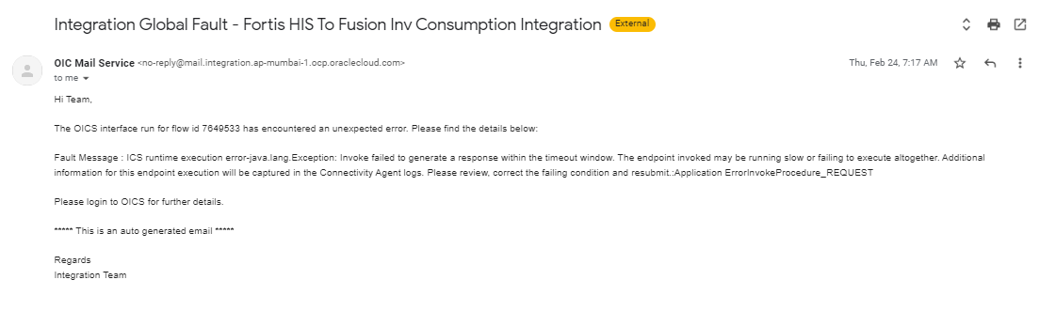

* If anything fails in the database PLSQL procedure, WHEN OTHERS exception has been handled everywhere which updates the error detail in XXFH_HIS_FILE_DETAILS_TBL for the given file name.
* To check if HIS has been sending the files regularly to Fusion, as this interface runs every half an hour and it’s a regular interface where transactions keep on getting punched in HIS. It can be checked using the following query:

The per day file count should be 48 if there was no downtime of either system : HIS or Fusion.

SELECT trunc(creation_date) cdate, count(1)

From XXFH_HIS_FILE_DETAILS_TBL

WHERE FILE_NAME like ‘Cons%’

GROUP BY trunc(creation_date)

ORDER BY trunc(creation_date) desc;

* Once the file is processed via Oracle PaaS in Oracle fusion, the integration triggers a notification with a status file as an attachment to notify the status against each & every transaction of that batch:

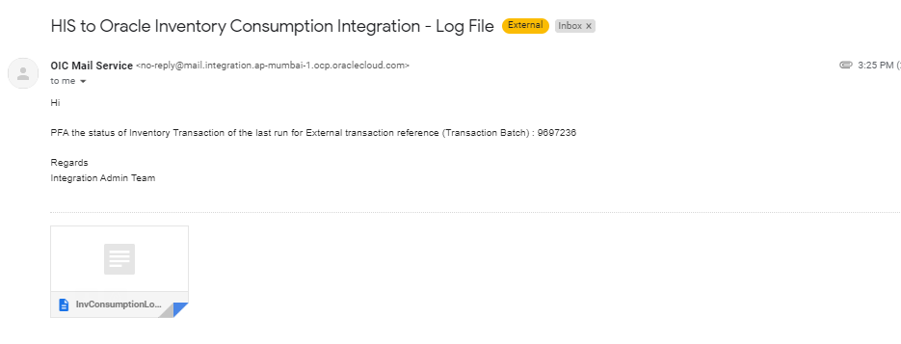

* In case, there is a record which has double inverted comma within that field value, then it will fail in sqlldr utility while loading the data from flat file to the table. Such errors cannot be notified as well. To check for such errors, the bad files under ‘/d01/inbound/HIS/Errors/” folder of DBCS SFTP can be checked periodically with partial file name as “*InventoryConsump*.bad”

# Assumptions / Considerations

The Proposed Solution will have the following technical considerations.

In the future, if any product bug arises in functionality then this process needs to be revisited after the bug is fixed.

# Open and Closed Issues

## Open Issues

| **ID** | **Issue** | **Resolution** | **Responsibility** | **Target Date** | **Impact Date** |
| --- | --- | --- | --- | --- | --- |
|  |  |  |  |  |  |
|  |  |  |  |  |  |
|  |  |  |  |  |  |
|  |  |  |  |  |  |

## Closed Issues

| **ID** | **Issue** | **Resolution** | **Responsibility** | **Target Date** | **Impact Date** |
| --- | --- | --- | --- | --- | --- |
|  |  |  |  |  |  |
|  |  |  |  |  |  |
|  |  |  |  |  |  |
|  |  |  |  |  |  |